## Document management

|  |  |  |  |
| --- | --- | --- | --- |
| **Version** | **Date** | **Author** | **Comments** |
|  |  |  |  |
|  |  |  |  |
|  |  |  |  |
|  |  |  |  |

## Control information

|  |  |
| --- | --- |
|  |  |
|  |  |
|  |  |
|  |  |
|  |  |

Table of contents:

Document management 1

Control information 1

Table of contents: 1

Case 1: Split open vendor transaction according to vendor bank accounts, description, vendor responsible 2

Case 2: Create vendor proposal 2

Functional specifications 3

Abbreviations 3

Changes of existing functionalities 3

New fields in form Transaction reorganizing 3

New functionality to split vendor open transaction 3

Issue list 4

Approvals 4

Description

The purpose of this development is to have possibility to split vendor open transaction according to vendor bank accounts, responsible, description. For this development standard form “Transaction reorganizing” (AP>Common>All vendors>Tab Invoice>Button Settle open transaction>mark a transaction>Transaction reorganizing button) form will be used.

### Case 1: Split open vendor transaction according to vendor bank accounts, description, vendor responsible

1. Go to AP>create a vendor invoice (amount – 1000)
2. Go to AP> Common>All vendors>Tab Invoice>Button Settle open transaction>mark a transaction>Transaction reorganizing button
3. Split open transaction in 2 lines according to specific details:

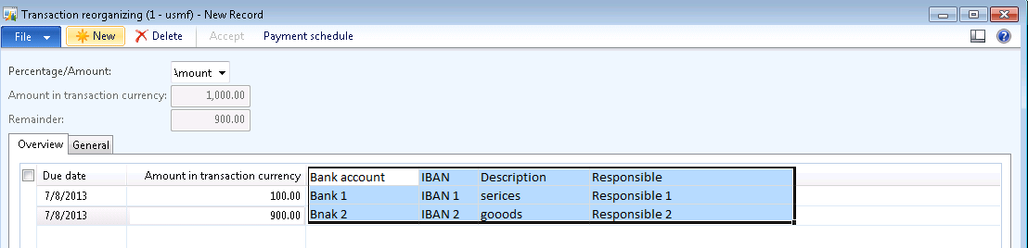

1. Press Accept button. 2 Line will be created in Open transaction form; new information will be display in Overview tab (Vendor bank account, IBAN, Description, and Responsible).

### Case 2: Create vendor proposal

1. Create a payment proposal for vendor previous used, select [Responsible 1] as filter criteria>only first line will be proposed for payment.
2. Create a payment proposal for vendor previous used, select [Bank 1] as filter criteria>only first line will be proposed for payment.
3. Create a payment proposal for vendor previous used>both lines will be proposed for payment.

## Functional specifications

### Abbreviations

N/A

### Changes of existing functionalities

#### New fields in form Transaction reorganizing

* New field in form Transaction reorganizing will be created in order to have possibility to split vendor open transaction according to vendor bank account, description, vendor responsible.
* These fields will not be mandatory

|  |  |  |  |
| --- | --- | --- | --- |
| **Field name (EN-GB & EN-US)** | **Type** | **Position** | **Details** |
| **Vendor Bank account**  **Banca furnizorului**  **IBAN**  **IBAN**  **Description**  **Descriere**  **Responsible**  **Responsabil** | Lookup  Display, not editable  String 70  Lookup | AP>Common>All vendors>Tab Invoice>Button Settle open transaction>mark a transaction>Transaction reorganizing button>Transaction reorganizing form) | Values from Status tables  Specific to Vendor bank account selected  Values from Employee table  Will be saved in VendTransOpen |

#### New functionality to split vendor open transaction

New functionality will be developed in order to have possibility to split vendor open transaction according to vendor bank account, description, vendor responsible.

New information will be display in Vendor Open Transaction form> Overview tab (Vendor bank account, IBAN, Description, and Responsible)

When a payment proposal is created (AP>Journals>Payment journal>Lines>Payment proposal button>Create payment proposal) and filters like [Responsible] or [vendor bank] account will be selected, only transaction fit specified filters will be proposed for payment.



Dependencies and assumptions

|  |  |
| --- | --- |
| **Description** | **Type (assumption/dependency)** |
|  |  |
|  |  |

## Issue list

|  |  |  |  |  |  |
| --- | --- | --- | --- | --- | --- |
| **Nr.** | **Issue description** | **Found by** | Resolution | Proposed by | **Status** |
|  |  |  |  |  |  |
|  |  |  |  |  |  |
|  |  |  |  |  |  |

## Approvals

|  |  |
| --- | --- |
| **Vendor** | **Customer** |
| Project manager: | Project manager: |